**Deterministic Logistics Planning Problems for an Air Cargo**

**Transport**

**Heuristic Analysis**

This is an analysis of three problems of air cargo transport using different search methods:

Problem 1 initial state and goal:

Init(At(C1, SFO) ∧ At(C2, JFK) ∧ At(P1, SFO) ∧ At(P2, JFK) ∧ Cargo(C1) ∧ Cargo(C2) ∧ Plane(P1) ∧ Plane(P2) ∧ Airport(JFK) ∧ Airport(SFO)) Goal(At(C1, JFK) ∧ At(C2, SFO))

Problem 2 initial state and goal:

Init(At(C1, SFO) ∧ At(C2, JFK) ∧ At(C3, ATL) ∧ At(P1, SFO) ∧ At(P2, JFK) ∧ At(P3, ATL) ∧ Cargo(C1) ∧ Cargo(C2) ∧ Cargo(C3) ∧ Plane(P1) ∧ Plane(P2) ∧ Plane(P3) ∧ Airport(JFK) ∧ Airport(SFO) ∧ Airport(ATL)) Goal(At(C1, JFK) ∧ At(C2, SFO) ∧ At(C3, SFO))

Problem 3 initial state and goal:

Init(At(C1, SFO) ∧ At(C2, JFK) ∧ At(C3, ATL) ∧ At(C4, ORD) ∧ At(P1, SFO) ∧ At(P2, JFK) ∧ Cargo(C1) ∧ Cargo(C2) ∧ Cargo(C3) ∧ Cargo(C4) ∧ Plane(P1) ∧ Plane(P2) ∧ Airport(JFK) ∧ Airport(SFO) ∧ Airport(ATL) ∧ Airport(ORD)) Goal(At(C1, JFK) ∧ At(C3, JFK) ∧ At(C2, SFO) ∧ At(C4, SFO))

**Part 1. Optimal Plans**

Optimal plans produced by A* Search ignoring preconditions heuristic:

1. For Problem 1 :
2. Load(C1, P1, SFO)
3. Fly(P1, SFO, JFK)
4. Unload(C1, P1, JFK)
5. Load(C2, P2, JFK)
6. Fly(P2, JFK, SFO)
7. Unload(C2, P2, SFO)
8. For Problem2:
9. Load(C3, P3, ATL)
10. Fly(P3, ATL, SFO)
11. Unload(C3, P3, SFO)
12. Load(C2, P2, JFK)
13. Fly(P2, JFK, SFO)
14. Unload(C2, P2, SFO)
15. Load(C1, P1, SFO)
16. Fly(P1, SFO, JFK)
17. Unload(C1, P1, JFK)
18. For Problem 3:
19. Load(C2, P2, JFK)
20. Fly(P2, JFK, ORD)
21. Load(C4, P2, ORD)
22. Fly(P2, ORD, SFO)
23. Unload(C4, P2, SFO)
24. Load(C1, P1, SFO)
25. Fly(P1, SFO, ATL)
26. Load(C3, P1, ATL)
27. Fly(P1, ATL, JFK)
28. Unload(C3, P1, JFK)
29. Unload(C1, P1, JFK)
30. Unload(C2, P2, SFO)

**Part 2. Uninformed Non-heuristic search**

In this part three uninformed non-heuristic search result metrics are compared i.e.

1. Breadth First Search (BFS)
2. Depth First Graph Search (DFS)
3. Uniform Cost Search (UCS)

The results are presented in Tab. 1:

Tab.1

|  |  |  |  |  |  |  |  |
| --- | --- | --- | --- | --- | --- | --- | --- |
| **Problem** | **Search** | **Expansions** | **Goal Tests** | **New Nodes** | **Time Elapsed [s]** | **Plan length** | **Optimal** |
| P1 | breadth_first_search | 43 | 56 | 180 | 0.05 | 6 | Yes |
| P1 | depth_first_graph_search | 12 | 13 | 48 | 0.01 | 12 | No |
| P1 | uniform_cost_search | 55 | 57 | 224 | 0.06 | 6 | Yes |
| P2 | breadth_first_search | 3343 | 4609 | 30509 | 11.48 | 9 | Yes |
| P2 | depth_first_graph_search | 582 | 583 | 5211 | 4.27 | 575 | No |
| P2 | uniform_cost_search | 4852 | 4854 | 44030 | 19.42 | 9 | Yes |
| P3 | breadth_first_search | 14663 | 18098 | 129631 | 81.56 | 12 | Yes |
| P3 | depth_first_graph_search | 627 | 628 | 5176 | 4.54 | 596 | No |
| P3 | uniform_cost_search | 18235 | 18237 | 159716 | 71.29 | 12 | Yes |

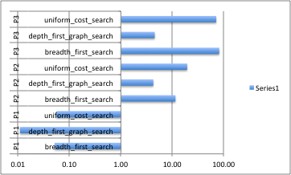

*Time Elapsed vs. Uniformed Search for P1, P2, P3 (log scale)*

Time needed to finish search (Time Elapsed) is the shortest for Depth First Graph Search. Uniform Cost Search and Breadth Firs Search took significantly longer especially for the most complicated Problem 3.

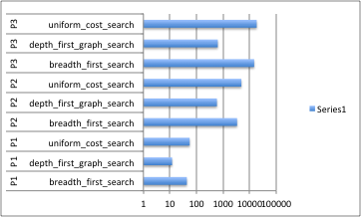

*New Nodes vs. Uniformed Search for P1, P2, P3 (log scale)*

Memory consumption can be analyzed through number of New Nodes expanded with the given search method. Depth First Graph Search expanded the fewest nodes whereas Uniform Cost Search required the most memory for its search.

Plan lengths produced by Breadth First Search and Uniform Cost Search are the optimal. Depth First Graph Search despite its better performance produced considerably longer paths therefore the results are not optimal.

**Part 3. Heuristic Search**

In this part 2 heurystic search result metrics are compared i.e.

1. A* Search with ‘Ignore Preconditions’
2. A* Search with ‘Level Sum’

The results are presented in Tab. 1:

Tab. 2

|  |  |  |  |  |  |  |  |
| --- | --- | --- | --- | --- | --- | --- | --- |
| **Problem** | **Search** | **Expansions** | **Goal Tests** | **New Nodes** | **Time Elapsed [s]** | **Plan length** | **Optimal** |
| P1 | astar_search h_ignore_preconditions | 41 | 43 | 170 | 0.05 | 6 | Yes |
| P1 | astar_search h_pg_levelsum | 11 | 13 | 50 | 1.01 | 6 | Yes |
| P2 | astar_search h_ignore_preconditions | 1450 | 1452 | 13303 | 4.92 | 9 | Yes |
| P2 | astar_search h_pg_levelsum | 84 | 88 | 841 | 95.35 | 9 | Yes |
| P3 | astar_search h_ignore_preconditions | 5040 | 5042 | 44944 | 20.03 | 12 | Yes |
| P3 | astar_search h_pg_levelsum | 318 | 320 | 2934 | 498.00 | 12 | Yes |

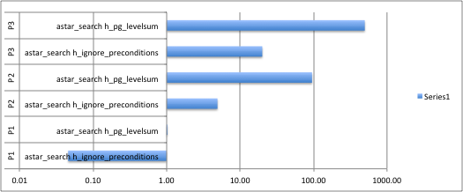

*Time Elapsed vs. A* Search with h for P1, P2, P3 (log scale)*

Computation time is much shorter for “Ignore Preconditions’ heuristic. That is probably due to complicated computation needed for Level Sum, in comparison to simple ‘Ignore Precondition’ heuristic.

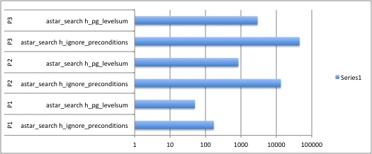

*New Nodes vs. A* Search with h for P1, P2, P3 (log scale)*

On the other hand, if we look at the number of New Nodes we can see that the first search needed significantly more memory to find the goal path.

Finally, both searches provided the optimal solution.

**Final Conclusion [1]**

Uninformed searches provided results that reflect the theory. BFS and UCS uninformed have exponential time and space complexities, O(bd ) and O(b1+⌊C∗/ε⌋), respectively whereas DFS has time complexity of O(bm) where m is max depth of search but linear space complexity O(bm), which is reflected in the New Nodes result (DFS result is significantly lower). Although low memory complexity of DFS could be advantageous, due to the nature of the search that explores a single branch till its max depth and stops when goal is achieved, the solution provided by DFS is not optimal therefore can’t be a good recommendation.

In the problems that analyzed here optimal uniformed searches provided solutions in relatively acceptable timeframe (especially for problems 1 and 2). BFS and UCS explore every branch in the tree search, which means that those searches will always provide an optimal solution, however time complexity of those searches can be problematic for very complex problems. The literature suggests that generally exponential complexity problems can’t be solved by uninformed searches and informed search strategies should be used. Informed search algorithms are better option for exponential problems, which is our case.

In the second part of the project A* search algorithm was used which estimates the cost of cheapest solution by minimizing the sum of path cost function from start to n node and heuristic function which estimates the cost from n to goal and is type of informed search algorithm.

One of the properties of A* is that “*the tree-search version of* A∗ *is optimal if heuristic function* *is admissible”*.

Since both our heuristics (‘Ignore Preconditions’ and ‘Level Sum’) are admissible therefore the solution is always optimal.

A* Search with ‘Ignore Preconditions’ seem the best choice in the set of problems given. First of all, the solution should be optimal, second of all the computation time should be the shortest, in order to make quick planning decisions. A* Search can have the worst – case space complexity similar to DFS or UCS but can do better. Therefore informed search can only win with optimal uninformed search. Despite larger memory requirements from the A* Search with ‘Ignore Preconditions’ provided optimal solution in the fastest time among informed search examined that provided optimal solution.

References:

[1] Artificial Intelligence: A Modern Approach, Third Edition, 1994 P. Norvig